Directions: Using your textbook and additional resources as necessary, use three distinct colors to shade in the map of early European colonial claims (French, Spanish, English) by 1700. After completing the map, answer the questions on page 2.
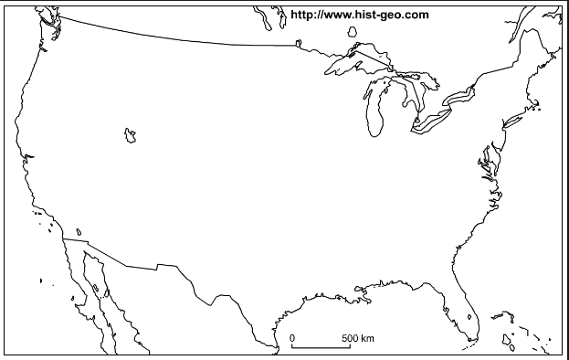

Directions: Answer the following questions with historical evidence.
- Describe what motivated the French, Spanish, and English settlers to move to the New World? Use both “pull” (what was significant about the New World that drew them there) as well as “push” (what was wrong with the Old World which prompted them to leave) factors.

- Describe the interactions between each colonizers and the Native Americans. Explain where the settled, which tribes they interacted with, and the nature of that interaction. Was the relationship ultimately beneficial to both group, colonizers and natives, or did it favor one over the other.
  - French:

  - Spanish:

  - English:

- Rate the treatment of Native Americans by the three colonizers above. Who was most tolerant? Who was most cruel? Give specific examples.

